**Lab 4: Inserting Initial Data into the Database**

Scenario:

The store manager wants to add initial product categories and products to the system.

Objective:

Use EF Core to insert records using AddAsync and SaveChangesAsync.

Code:

Program.cs

using Microsoft.EntityFrameworkCore;

using RetailInventory;

class Program

{

static async Task Main(string[] args)

{

using var context = new AppDbContext();

// Add categories

var electronics = new Category { Name = "Electronics" };

var groceries = new Category { Name = "Groceries" };

await context.Categories.AddRangeAsync(electronics, groceries);

await context.SaveChangesAsync();

// Add products

var product1 = new Product { Name = "Smartphone", Price = 25000, CategoryId = electronics.Id };

var product2 = new Product { Name = "Milk", Price = 50, CategoryId = groceries.Id };

var product3 = new Product { Name = "Laptop", Price = 20000, CategoryId = electronics.Id };

await context.Products.AddRangeAsync(product1, product2, product3);

await context.SaveChangesAsync();

}

}

After that, the application is run using dotnet run command and then the verification is done that all the data are inserted correctly.

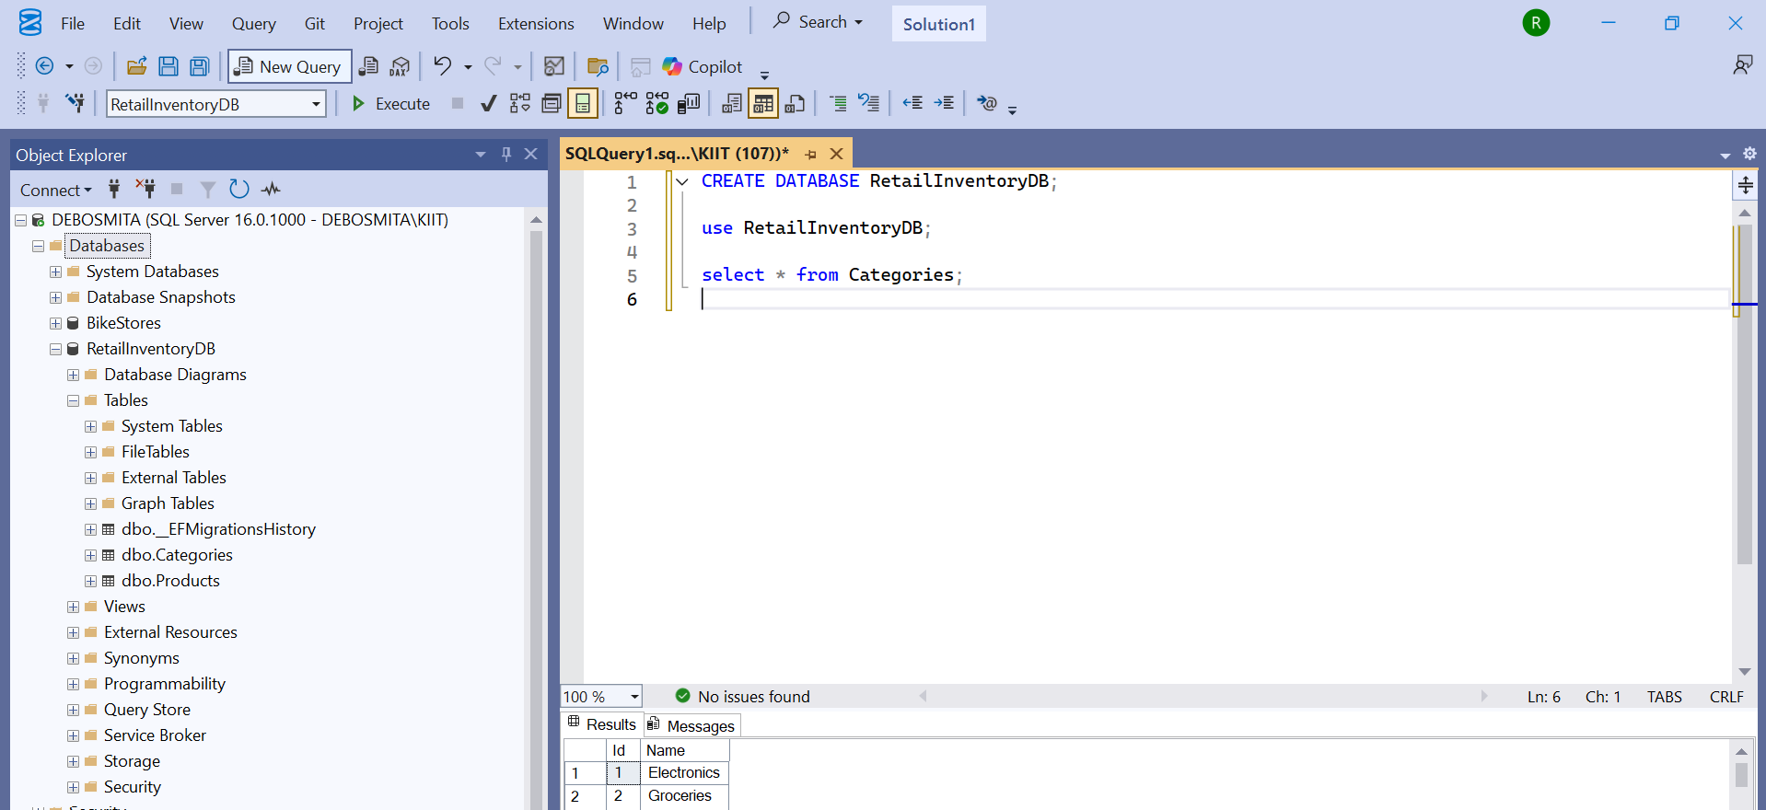

This is for Category table.

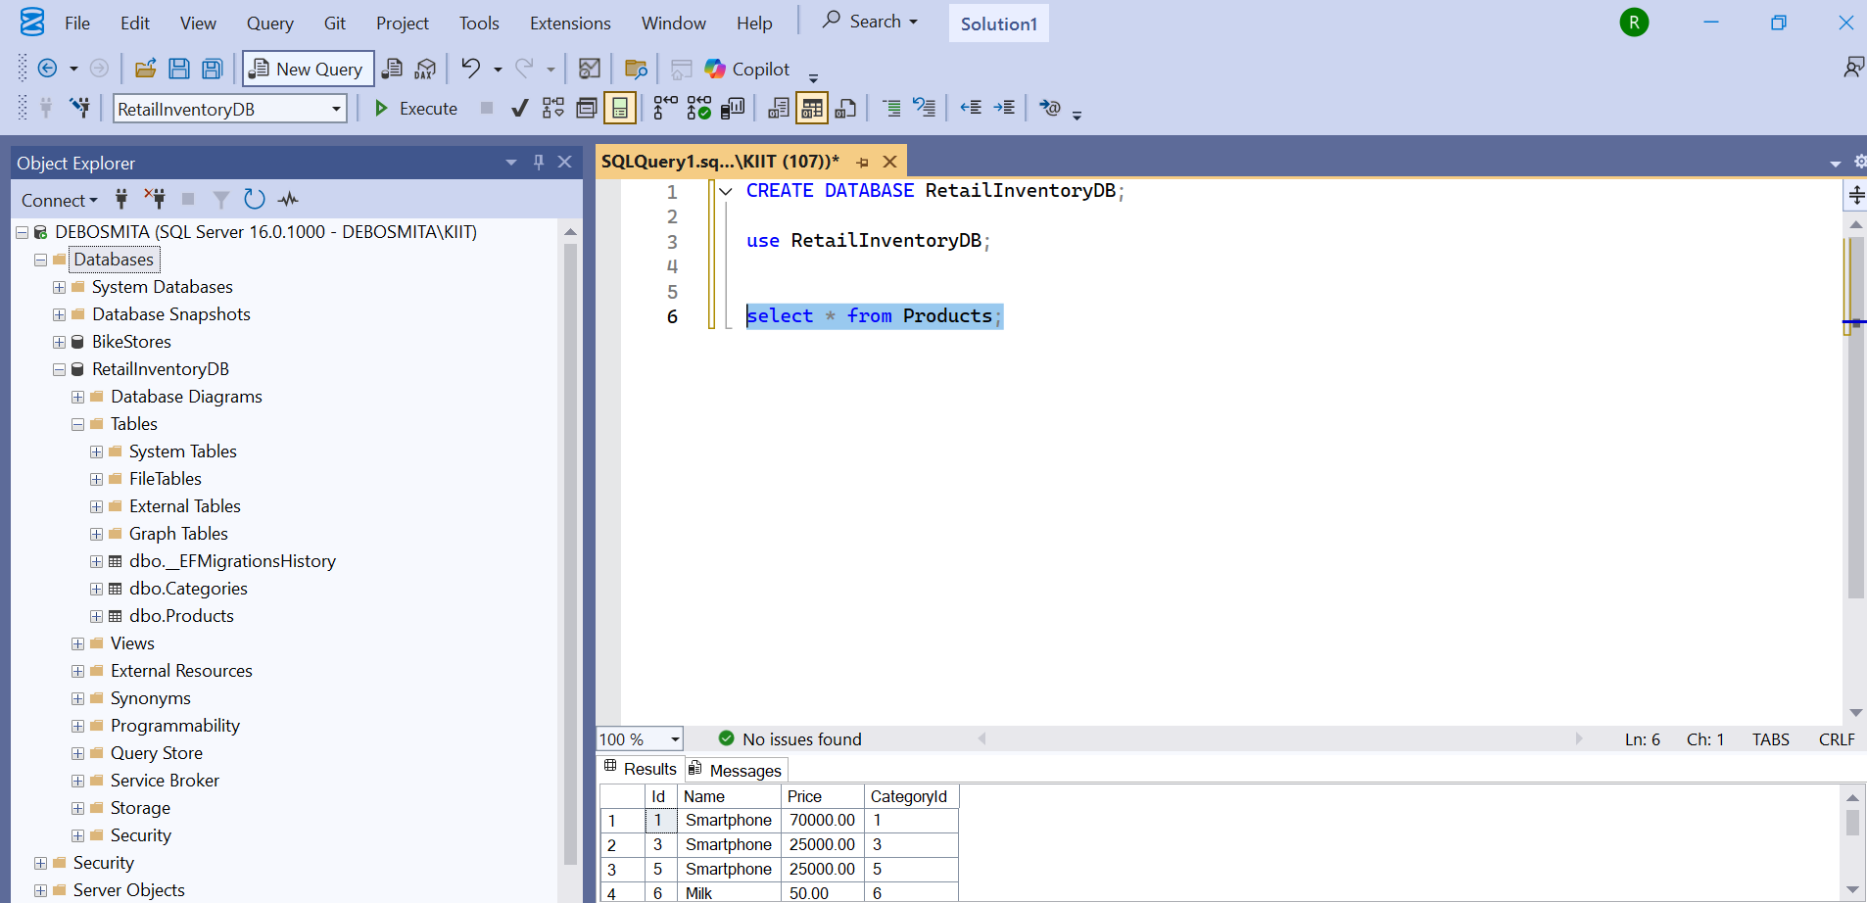

This is for Product table.